**REPORT ON BANK**

**ACCOUNT**



**Submitted by: Sampurna Gautam Submitted to: Mrs. ﻿Saroj Sharma**

**Level 3 semester 1 Module instructor of “Introduction of**

**BSC (Hons) Computing Programming”**

**Section “E”**

**Uwe Id - 23045147**

**Orbund Id - 9750**

**DATE: May 1, 2023**

**Acknowledgment**

I received a lot of assistance from others to finish this project. I want to express my gratitude to everyone who assisted me. I want to thank Mr. Saroj Sharma, the teacher of my class, in particular, for his support and encouragement.

**Abstract**

The "Bank Account Project" is a program that helps individuals to keep track of their bank accounts. This project not only demonstrates how a financial system operates but also covers the key features of bank management software. Additionally, this project is created to assist a customer in resolving their financial tasks in a banking setting. With this initiative, users can carry out banking tasks in a variety of ways and bank employees can assist customers by carrying out financial transactions. This project's main objective is to build a financial institution with a menu-driven software system.

**Bank Account Project Proposal**

**Project introduction**: The bank account project assists a financial organization in controlling customer deposits and withdrawals. Additionally, it determines the bank's monthly interest rate and processing charges.

**Project objectives**: The goal of the Bank Account project is to provide a perfect menu-driven software system that will facilitate easier communication between various banking components.

**Project Scope**: The system allows individuals to open up two distinct accounts at the bank using the Savings Account and Checking Account service. As a result, they may open and use these accounts from the convenience of their computer without having to visit the bank. Moreover, this program allows customers to view the monthly balance and activity of the account.

**Project description**

This article describes the operation of a financial institution's menu-driven software system. This system enables bank employees to provide financial services to customers by opening accounts, making deposits, withdrawing money and looking up customer information. The Bank Account class, Savings Account class, and Checking Account class are the three main classes utilized in this system.

**Bank Account:** The Bank Account class, which represents a bank account and includes crucial data including a balance, interest rate, and the number of deposits and withdrawals, has declarations in the Bank Account.h file. The amount, interest rate and quantity of deposits and withdrawals are among the few of the member variables that make up the Bank Account class. The class also has virtual functions for making deposits and withdrawals, calculating interest, and processing monthly transactions in addition to accessor and mutator methods for these member variables. This header file additionally defines the Service and Owed structure too. The monthly Proc method of the Bank Account class is used to return the service fees and total amount owed.

**Savings Account:** Definitions for the Savings Account class, a subclass of the Bank Account class, can be located in the Savings Account. h file. An active or inactive account is indicated by the status variable of the Savings Account class. Additionally, the Active public function in the class returns the account's status. To provide additional functionality exclusive to a savings account, the Savings Account class overrides the make withdrawal and monthly Proc capabilities of the Bank Account class**.**

**Checking Account**: A header file called Checking Account. h is a class that is derived from the Bank Account class. This class has a member variable called owing that represents how much money the client owes the bank. The class provides a constructor that accepts an annual interest rate and balance and initializes the amount owed to 0. Additionally, it has a function called an accessor that returns the value of the debt. A virtual function called monthly Proc, which is part of the class is used to process the account's monthly costs. This function adds a $5 monthly fee plus $0.10 for each withdrawal to the base class variable that stores the monthly service costs before calling the base class function. The class contains a virtual function called make Withdrawal that is used to make a withdrawal (a check) from the account. This function determines if the withdrawal will result in a balance that is lower than zero. If it does, a $15 service fee is deducted from the account along with an error message. The customer will owe the bank the negative amount if the balance falls below zero. The base class method "make withdrawal" is called to subtract the amount of the withdrawal from the balance if the balance is more than the amount of the withdrawal.

**Main:** The program aids in keeping track of bank accounts by entering the account details and making transactions. It analyzes the monthly interest rate, reduces the monthly service cost from the balance and then adds any other fees or penalties.

**Project’s Output**

Bank employees can deposit money, withdraw money and search for customer information with the useof the banking system.

**1**.**Creating Bank Account**

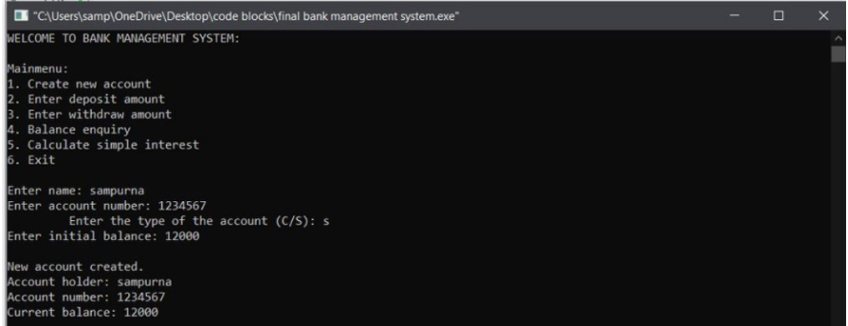

**2. Deposit Amount**

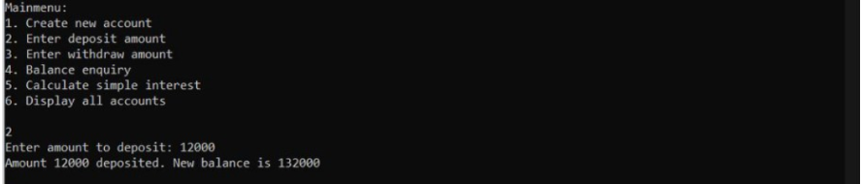

**3.Withdraw Amount**

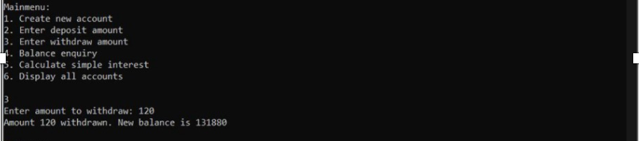

**4. Balance Inquiry**

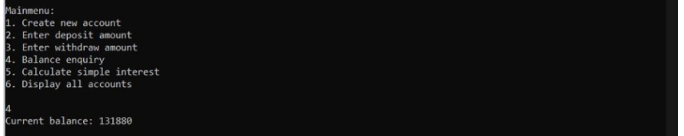

**5. Simple Interest**

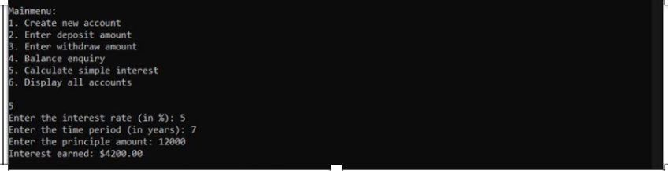

**6. Exit**

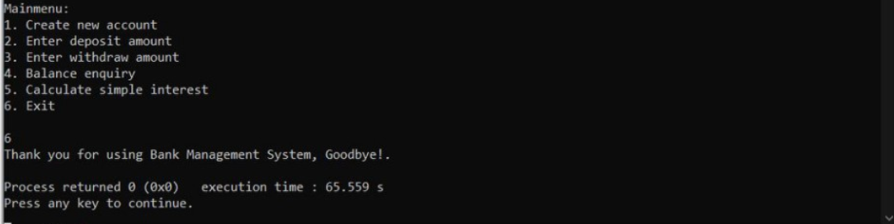

**References**

1. <https://t4tutorials.com/bank-management-system-project-in-c/> for menu-driven software system
2. <https://www.geeksforgeeks.org/menu-driven-program-for-bank-management-system/> for menu-driven software system